Temasek Polytechnic
School of Informatics and IT

Diploma in Information Technology (IT)

Project Plan

Project Particulars

Tutor | Mr Qi Yutao
Class | P02
Project Title | Delonix Regia Hotel Management System

Project Team’s Particulars

Matric Number | Student Name
1301354E | Chan Zhi Mai
1300647C | Aaron Lim JieKai
1306307H | ZhiYong Chew
1302901B | Nurul Hidayah Hamzah

Revision History

Date | Version | Description | Author
27/04/2015 | 1.1 | Term Of Reference | Chan Zhi Mai
28/04/2015 | 1.2 | Project Plan | Chan Zhi Mai
29/04/2015 | 1.3 | Term Of Reference, Project Plan | Chan Zhi Mai
30/04/2015 | 1.4 | Term Of Reference, Project Plan | Chan Zhi Mai
01/05/2015 | 1.5 | Project Plan | Chan Zhi Mai

Table of Contents

- Introduction
  - Objectives and scope of the project
  - Assumptions and constraints
  - Definitions and acronyms

- Roles and responsibilities

- Estimates and project schedule
  - Work breakdown structure
  - Project schedule
  - Budget summary

- Risk management plan
Project Plan

- Introduction

  - Objectives and scope of the project

Room Booking Module
We will offer online hotel rooms reservation where customer can make hotel room reservation using the hotel’s web application. Information will be integrated and save in a centralized database for easier insert, retrieve, update and delete of information. In the Room Booking Module, it can generate computerized reports for business records such as Cashier Reports so as to record the revenue earned from each customer per transactions.

Features:

1. Availability Status
Availability Status allows front desk staff to check hotel room’s availability for each different types of hotel rooms. Whenever customers who wants to stay in the hotel, they will choose a type of room and Availability Status will tell the front desk staff the number of rooms available of that particular room type requested by the customer. E.g. Deluxe Room – Available (30).

2. Room Reservation
Room Reservation allows online and walk-in customer to make hotel rooms reservation. Front desk staff/customer will have to enter information such as customer name, arrival date, departure date and the numbers of hotel rooms requested.
3. Arrival List
Arrival List records the details of all check-in customer. It stores customer’s information such as customer name, room number and arrival date. This is for business records so that the company hotel management will know how many customer have check-in to the hotel room on a daily basis.

4. Reservation List
Reservation List records the details of all walk-in and online customer who have make hotel room reservation with the hotel. The purpose of Reservation List is for front desk staff to serve customer efficiently as customer's information and request has already been stored in the Hotel Management System when they make their hotel room reservation.

5. Room Status
Room Status allows front desk staff to check the status of the particular room. It will show the details of the room such as the number of bed and the size of the bed in the room. E.g. when customer request for a queen sized bed and with Room Status’s feature, the front desk staff will know which rooms have a queen sized bed.

6. Telephone Calls
The hotel provides Telephone Calls service for their customer. This feature will records customer’s usage of the Telephone Calls service. It includes information such as the number called, the date and time of the call and the charges.

7. Check-In
Check-In provides an interface for front desk staff to help customers to check-in to their hotel rooms.

8. Check-Out
Check-Out provides an interface for front desk staff to help customers to check-out of their hotel rooms.

9. Departure List
Departure List records the details of all check-out customer. It stores customer’s information such as customer name, room number and departure date. This is for business records so that the hotel management will know how many customer have check-out of their hotel room on a daily basis.

10. Cashier Report
Cashier Report records the transactions of the hotel rooms. It can retrieve from the hotel management system only a yearly, monthly or daily basis. This is for business records so that the hotel will know the details of their revenue earned. Cashier Report shows information such as bill amount, room number and the date of transaction.

11. Occupancy
Occupancy records all customer which is currently staying in the hotel. This feature enables front desk staff to search for customer who is staying in the hotel. E.g. whenever someone who wants to find a customer staying in the hotel, the front desk staff will assist the person by using Occupancy feature.

12. Billing
Billing is an interface on the Point-Of-Sale system where front desk staff will get customer's invoice and print it for the check-out customer to view and pay for it.

Finance and Accounting Module
By implementing the finance and accounting software, it will allow Delonix Regia staff to handle the accounts, billing invoice and view financial report efficiently and effectively. Foreign guests can also use their own to currencies as this system can manage different currencies.

Features:

1. Basic Functions
• Management of general, analytic and auxiliary accounts.
• Multilevel charts without limit on codes or levels.
• Management of virtual accounts
• Ability to work on several fiscal year at the same time.
• Management of partial closure.

2. Seized accountancy
• 5 modes of entry: by documents, quick entry in list mode, models, subscription.
• Automation of counterparts and taxes: by account, by partner or by products.
• Entries automatically created thanks to the integration of the other modules of ERP.

3. Numerous Automation
• Automatic description, VAT computation, automatic due-date computation, automatic counterparts, third party payments management, balance and creation of accounts while creating entries.
• Tailored models entries.
• 100% Keyboard interaction.

4. Third party management
• Multilevel plans without any limit.
• Mass mailing, mass SMS send.
• Custom and multilevel follow ups and payment terms.

5. Reconciliation
• Manual check of bank accounts.
• Generation of reconciliation accounts
• Automatic reconciliation by accounts or in real time: 9 level of computation.

6. Multi's
• Unlimited currencies.
• Multiple units of measure and automated conversions.
• Multi companies with their respective architecture.
• Simultaneous multiusers thanks to the client/server mode.
• Multiple general and analytic charts.
• Management of Double unit measures.

7. Numerous Controls
• Precise rights management thanks to the possibility to define multiple company levels, groups, users and roles.
• Control entries at the account, journals or products level.

8. Integration of modules
• Completely integrated to the other modules
• Management by project integrated with the analytical accounting (Timesheet).
• Automated general and analytic imputations: Stock movement, production.
• Several logics of automated invoice creation.
9. Financial Reports
• Balance, ledgers, accounting journals, bill books, reminder.
• Preliminary state of VAT declaration.
• Balance sheet, Income statement and intermediate balance of management.
• Comparative multi-exercises
• Intra-company and intra stats declaration.
• Analytic state, budgetary state, reporting state, Cash control.
• Customization and creation of personalized documents

10. Analytic
• Multilevel analytic plans and unlimited journals
• Validation of unlimited and automated accounting moves according to numerous criteria
• Interrogations and editions
• Control of Cost system, management by business and interaction with projects, time sheet, sales and purchases, and production.

11. Budgeting
• Unlimited budgets on products, charges, stock or treasuries.
• Wizard to create notations.
• Budgetary reports

Housekeeping Module
By implementing the housekeeping management software allows the room attendants and their supervisor at Delonix Regia hotel to fully make use of the management system for their daily work more efficiently and effectively. Staffs in Delonix Regia hotel can also perform their work done on time as according to their desired standards and thus, fulfilling the sanitation requirements of the hotel more tactfully. Lastly, it also will boost up the hotel earnings by many folds.
Features:

1. Basic Functions
• Management of housekeeping activities
• Management of room housekeeping
• Management of room inspection

2. Activities
• Activities type
• Activities management

3. Housekeeping orders
• Management schedule of cleaning
• Allocation of cleaner
• Allocation of inspector
• Management inspection of cleaning
• Type of services in order
• Remarks of services in order

Human Resource Module
By implementing human resource management system, it allows functions such as leave applications, and generating payroll, reports and employee’s timetable/ timesheets. The system will be able to record basic demographic and address data, selection, training and development, capabilities and skills management, compensation planning records and other related activities. It provides the ability to run applications and enter relevant data to applicable database fields, notify employers and provide position management and position control. Employees can also query their attendance record, apply for leave and check their work timetable from the system without asking the information from HR personnel. Subsequently, it lets supervisors to approve O.T and leave application requests from their subordinates through the system. For example, if one of the employee apply leave through this system, his supervisor is able to review schedules and re-assign duties promptly. Additionally, the management will be able to keep track of the employees’ attendance and their performance for job promotion or rise of salary.

Features:

1. Payroll
• Refers to the administration of employees’ salaries, wages, bonuses, net pay, and deductions.
• It consist of the employee ID, employee name, date of joining, daily attendance record, basic salary, allowances, overtime pay, bonus, commissions, incentives, pay for holiday, vacations and sickness, value of meals and lodging etc..

2. Database for employee information
• It consist of all the employee’s information such as name, mobile number and address, for emergency use.

3. Attendance records
• Includes their number if hours of work and their attendance rate.
• Supervisors are able to track employee’s absenteeism for discipline.

4. Management of Absences/ Leave application
• The employees are able to apply for their leave.
• It consist of the dates and reasons for the employee’s leave.
• Supervisors are able to validate their leave application.

5. Employee scheduling
• Timetable/ timesheets for the employees that has been assigned by their supervisors.
• It consist of all the days and specifically which shifts and duties are they assigned to.

6. Performance Appraisal
• Understand each employee’s abilities, competencies and relative merit and worth for the organization.
• Rates the employees in terms of their performance.
• Mostly used for job promotions or rise of salary.
• Half/Yearly report.

  - Assumptions and constraints

Below are the assumptions for the project,
• Assumed that the project will go on smoothly as time planned and be able to deliver the project to the hotel on time.
• Assumed that the manpower for the project will stay throughout the entire work schedule.
• Assumed that the hardware such as, computers, servers will deliver on time and able to configure as such for the project.
• Assumed that there are sufficient hardware and software to complete the project without failing.
• Assumed that there will be no issues upon integrating with the hotel and it will work as planned.

Below are the constraints for the projects,
• As the work research we are doing are based on individual parts. Upon collaborating and integrating our work into a complete piece, different formats might occur as we did not agree to a standard format to follow.
• The work load for different module for different team members will be higher as certain module contains many other sub-features. Thus, we might expect it not able to deliver the product as what is stated in the report.
• The time given to complete the product is very limited. We might not be able to deliver the product on time as it will be very rush on our team members.
• Software availability is also a constraint, as certain Microsoft products requires license to purchase in order to use for this product. Thus, due to the licensing issue we are only limited to use the school VMWare to access to the license software.
• Manpower for the project will be another constraint as we might be hiring too much manpower for the project or worried that there are too little manpower for the project.

  - Definitions and acronyms
HR – Human Resource
O.T. – Over Time
E.g. – Example
VAT – Value-added tax

- Roles and responsibilities
Roles and Responsibilities | Members
Term of Reference
Introduction | Chan Zhi Mai (1301354E)
Objectives of the Project | All
- Room Booking Module | Chan Zhi Mai (1301354E)
- Finance and Accounting Module | Aaron Lim JieKai (1300647C)
- Housekeeping Module | ZhiYong Chew (1306307H)
- Human Resource Module | Nurul Hidayah Hamzah (1302901B)
Scope of the Project | All
- Room Booking Module | Chan Zhi Mai (1301354E)
- Finance and Accounting Module | Aaron Lim JieKai (1300647C)
- Housekeeping Module | ZhiYong Chew (1306307H)
- Human Resource Module | Nurul Hidayah Hamzah (1302901B)
Distribution of Workload | Chan Zhi Mai (1301354E)
Constraints | ZhiYong Chew (1306307H)
Resources | Chan Zhi Mai (1301354E)
Product Positioning in the Market/Company | Aaron Lim JieKai (1300647C)
Approach and Methodology of the Project | Nurul Hidayah Hamzah (1302901B)
Project Plan
Introduction
- Objectives and scope of the project | Chan Zhi Mai (1301354E)
- Assumptions and constraints | ZhiYong Chew (1306307H)
- Definitions and acronyms | Chan Zhi Mai (1301354E)
Roles and responsibilities | Chan Zhi Mai (1301354E)
Estimates and project schedule
- Work breakdown structure | All
- Project schedule | All
- Budget summary | Chan Zhi Mai (1301354E)
Risk management plan | All except Chan Zhi Mai (1301354E)

- Estimates and project schedule

  - Work breakdown structure
Hotel Management System Project
1 Initiate Project
1.1 Develop Term of References
1.1.1 Define Scope and Requirement
1.1.2 Determine Project Team
1.1.2.1 Determine Project Manager
1.1.2.2 Determine Development Team
1.1.2.3 Determine Programming Team
1.1.3 Determine Project Positioning
1.1.4 Finalize Term of References and Gain Approvals
1.1.4.1 Consolidate Term of References
1.1.4.2 Hold Review Meeting
1.1.4.3 Revise Project Term of References
1.1.4.4 Gain Approvals

2 Plan Project Plan
2.1 Develop Work Plan
2.1.1 Develop Work Breakdown Structure
2.1.2 Develop Project Staffing Plan
2.1.3 Develop Project Schedule
2.1.4 Develop Project Budget
2.1.5 Develop Risk Management Plan

2.2 Finalize Project Plan and Gain Approvals
2.2.1 Consolidate Project Plan
2.2.2 Hold Review Meeting
2.2.3 Revise Project charter
2.2.4 Gain approvals

3 Installation and Configuration
3.1 Procure Hardware/Software
3.1.1 Install Development System
3.1.2 Install Live System
3.1.3 Configure System

4 Execute Project
4.1 Design Framework
4.1.1 Define framework stages and activities
4.1.2 Design framework content formats
4.1.3 Design web framework delivery tool
4.2 Build the Framework
4.2.1 Write the framework content
4.2.2 Review framework content for quality
4.2.3 Build hotel management system
4.2.3.1 Room Booking Module
4.2.3.2 Finance Module
4.2.3.3 Housekeeping Module
4.2.3.4 Human Resource Module
4.3 Implement Framework
4.3.1 Test usability of web tool
4.3.2 Test usability of content
4.3.3 Adjust framework based on user feedback
4.4 Test the Framework
4.4.1 Move framework to production environment
4.4.2 Announce availability of framework
4.5 Deployment

5 Close the Project
5.1 Maintenance

  - Project schedule
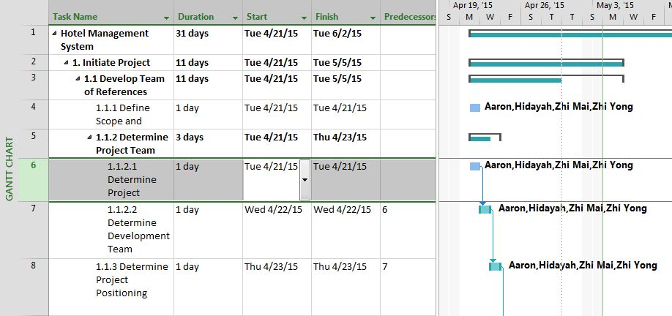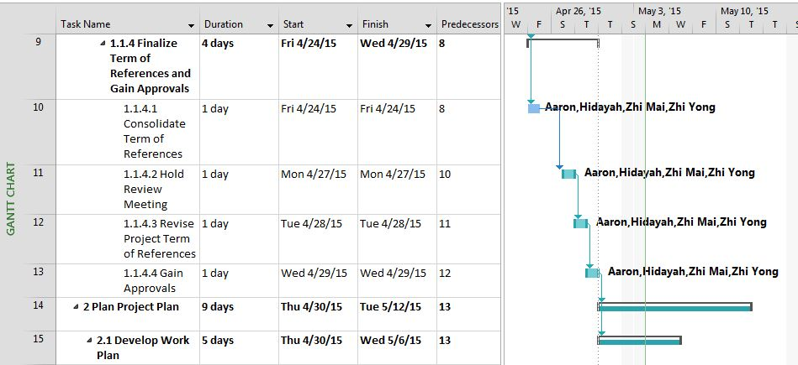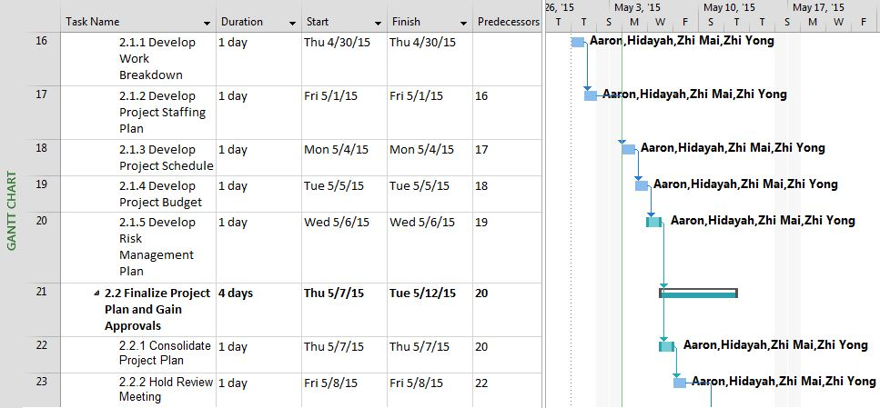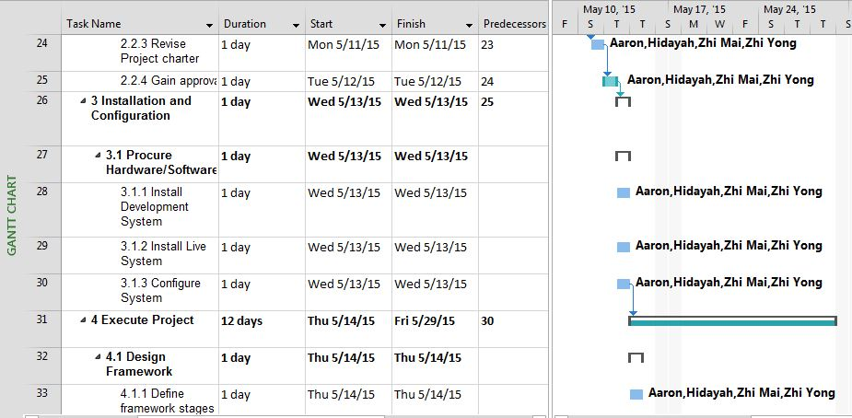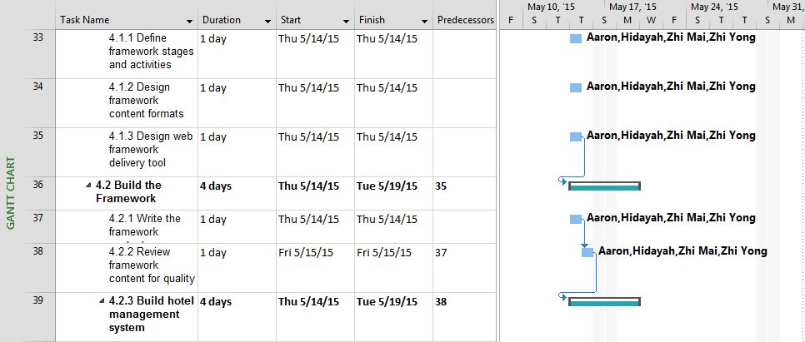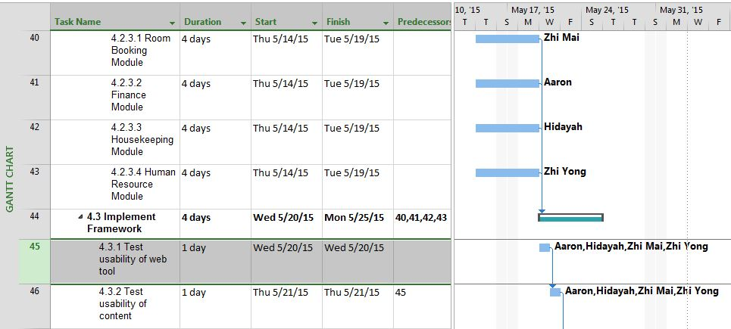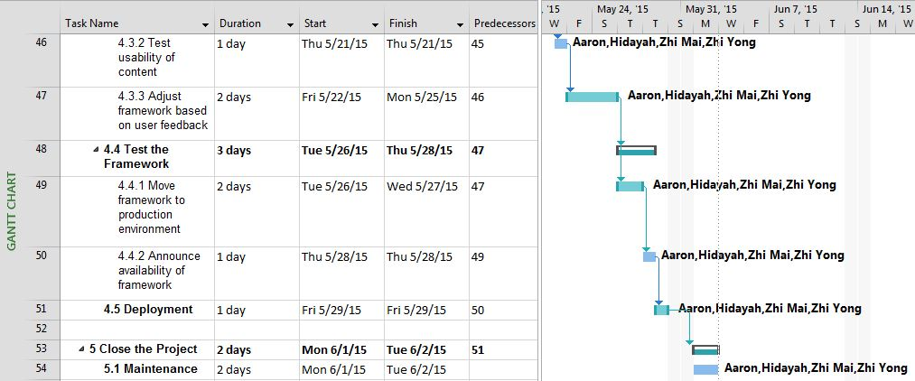

  - Budget summary

Delonix Regia Hotel Management System
Labour Expenses
Members | Salary ($)/month | Time needed (Months) | Total Salary ($)
Chan Zhi Mai | 1,000 | 2 | 2,000
Aaron Lim JieKai | 1,000 | 2 | 2,000
ZhiYong Chew | 1,000 | 2 | 2,000
Nurul Hidayah Hamzah | 1,000 | 2 | 2,000
Subtotal: |  |  | 8,000
Hardware Expenses
Resources | Cost ($) /quantity | Quantity | Total Cost ($)
Brother MFC-J470DW Printer | 218.00 | 1 | 218.00
ASUS ET2321INTH All-In-One PC | 1499.00 | 1 | 1499.00
Casio TE-2200 Cash Register with Honeywell MS-9520 Scanner Receipt Printer | 698.00 | 1 | 698.00
Nets Terminal | 40.00 | 1 | 40.00
Citibank Credit Card Terminal | 246.00 | 1 | 246.00
Subtotal: |  |  | 2701.00
Software Expenses
Resources | Cost ($) /quantity | Quantity | Total Cost ($)
Microsoft Office 2013 | FREE | 1 | FREE
Microsoft Visual Studio | FREE | 1 | FREE
Microsoft Security Essentials | FREE | 1 | FREE
SQL Management Studio | FREE | 1 | FREE
Tableau 8.3 | FREE | 1 | FREE
Subtotal: |  |  | FREE
Other Expenses
Resources | Cost ($) /quantity | Quantity | Total Cost ($)
Credit Card Terminal Annual Fees | 385.00 | 1 | 385.00 (Annually)
Nets Terminal Annual Fees | 456.00 | 1 | 456.00 (Annually)
Subtotal: |  |  | 841.00
Total Cost of the project: |  |  | 11542.00

Resources | Uses/Explanation
Labour Expenses | Manpower
Brother MFC-J470DW Printer | Print document such as customer invoice
ASUS ET2321INTH All-In-One PC | A computer for accessing the Hotel Management System
Casio TE-2200 Cash Register with Honeywell MS-9520 Scanner Receipt Printer | To store cash in the cash register for hotel’s cash transaction.
Nets Terminal | A terminal which allows customer to pay hotel service using Nets.
Citibank Credit Card Terminal | A terminal which allows customer to pay hotel service using Credit Card.
Microsoft Office 2013 | Office support tools to operate the business.
Microsoft Visual Studio | To create web application and interface for the Hotel Management System.
Microsoft Security Essentials | Antivirus software to protect the Hotel Management System from virus.
SQL Management Studio | To create database to store information for the business
Tableau 8.3 | To create Dashboard to generate computerized report for the business.
Credit Card Terminal Annual Fees | Credit card terminal service fees
Nets Terminal Annual Fees | Nets terminal service fees

- Risk management plan
Below are some possible risks that the hotel may face in the upcoming years or in future:

Financial Risk
Hotel may face cash-flow money issue as global economic crisis may arise in future. Thus, the hotel may not achieve its business and profit margins. To reduce the risk so that the hotel will not face such issue in future, the hotel may use the approach to come up with promotions, discounts, lucky draws to attract customers to continue to visit the hotel, and if such approach are good, customers will eventually use their mouth-to-mouth to let more people know about the hotel.

Reputational Risk
Hotel reputation is very significant for hotel as competitive is growing in the fast market nowadays. The likelihood of this risk arising is moderate as long as the hotel provides customers great service. As reputation is becoming a key source of competitive advantage. Customers who visits the hotel will first check on the Internet to see which grade of hotel that hotel is. Thus, having a bad reputation for a hotel will lead to customers not keen to book this hotel. To reduce the risk from arising at any point of time, the hotel can ensure that all staffs are well-trained and provide good services to customers at any time.

Safety Risk
The public or guests who are staying with us or within the hotel premises may injured themselves, a slips, trips or falls might cause them to injure in the hotel. The likelihood of this risk arising is likely to happen as people sometimes are not that careful and thus leading to injuries. To reduce the risk from arising and if such issue happens, the hotel may engage employees to attend safety risk courses that can train the employees to help handle such situation if it happen at any time.
Information Systems Risk
The Hotel will be reliable on technologies and the management system for the operation of its business. Any material disruption or slowdown of the management system, especially any failures relating to its room booking module, could cause valuable information to be lost or operations to be delayed. Additionally, the Hotel will be maintaining and handling personal customers’ data, and also employee data, through the hotel management system itself. Thus, such information may be misused by employees of the Hotel or outsiders if there is an inappropriate or unauthorized access to the relevant information systems. To reduce this risk from constantly arising, the Hotel have to ensure at least monthly system updates and inspections to prevent any system disruption from happening, and have to implement a variety of security measures in order to maintain the safety of personal customer information and to prevent outsiders from hacking in into the system.

Technology Risk
This risk is that the hotel is unable to keep pace with developments in technology could damage operation or competitive position. As hospitality industry demand the use of sophisticated technology and systems including those reservation, revenue management and property management systems and technologies that are available for guests during their stay. These technologies and systems must be refined, updated or replaced with more advanced systems on a regular basics. If the hotel is unable to do as quickly as compared to competitors or could not afford to change or update the system, it will cause the business to suffer. To reduce the risk from arising, hotel can find technologies that is cheap and easy to update and also software that is flexible to implement news features or update.

Appendix

http://welcome.brother.com/sg-en/products-services/multi-function-centres/MFC-J470DW.tab1.html

http://www.courts.com.sg/aio-pc-intel-core-i54200u-8gb-1tb-win-81-genpr-64897-m.html

http://www.cashregisterstore.com/xcart/Casio-TE-2200-Cash-Register-w-Honeywell-MS-9520-Scanner-w-Free-Lifetime-Technical-Support.html

http://bigspoon.sg/blog/choosing-card-payment-terminal-fb-outlet-singapore/

